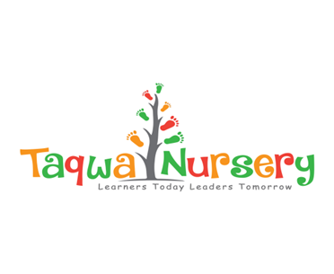
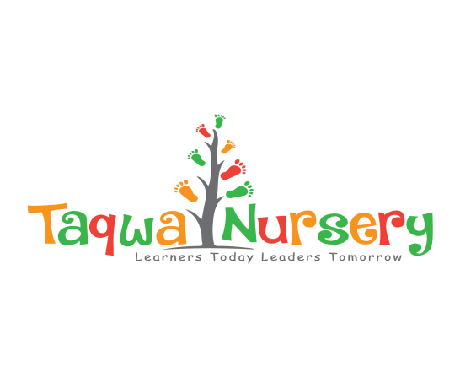

NURSERY TEACHER POST
FULL/PART TIME. OPTION TO START STRAIGHT AWAY AS SOON AS DOCUMENTATION HAS BEEN CHECKED
The successful candidate will need to be appropriately qualified: NVQ Level 3, highly motivated, energetic, enthusiastic and committed in providing high quality physical, social and intellectual care and support in a fun, safe and spiritual environment for 2-5 year olds.
Main Duties and Responsibilities will include:
To ensure children’s social and emotional needs are met through the use of an effective settling in period. To provide children with an opportunity to build supportive relationships with staff and their key person to make them feel safe, secure and confident to play, explore and develop.
To implement the revised Early Years Foundation Stage (EYFS) curriculum, leading on planning and implementing effectively, ensuring children’s’ interests and experiences are suitable to their age range, stimulating, differentiated and encouraging development within the field and embedded within their day.
To be confident in the procedures to safeguard and protect children.
To support the Manager in the overall observation, assessment and recording of development with reference to the Nursery Policies, EYFS and Ofsted regulations.
Provide high standards of quality within the nursery including the environment, resources and experiences offered to children.
Promote and facilitate positive partnership with other agencies and parents/guardians.
You will need to have the following qualifications: Qualified to NVQ Level 3 or equivalent; Teaching experience is desirable but not necessary.
Have a sound knowledge and understanding of the EYFS and safeguarding documentation
Taqwa Nursery is committed to ensuring you will receive ongoing training and continuous professional development.
Taqwa Nursery is committed to the safeguarding and protection of the children in its care and as such implement a strict safer recruitment culture - the successful applicant will be required to complete an enhanced DBS Disclosure. References will be taken up prior to interview.

